Teamcenter installation://turn off firewall during installation
1.java installation
2.oracle installtion
3.teamcenter installation
java installation:
- copy jdk_8u65-window-*64 from 192.168.2.150 and paste to your disk

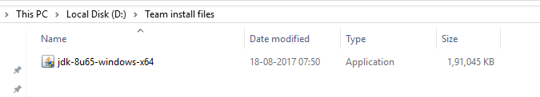
2.run as administrator

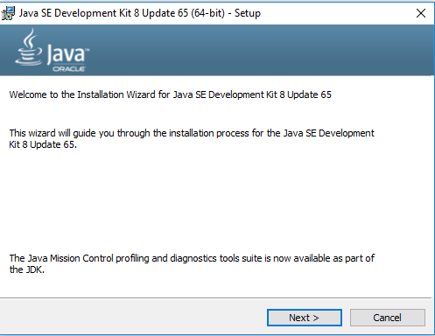

3.click “next”
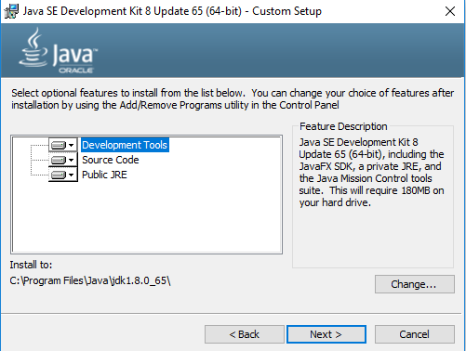
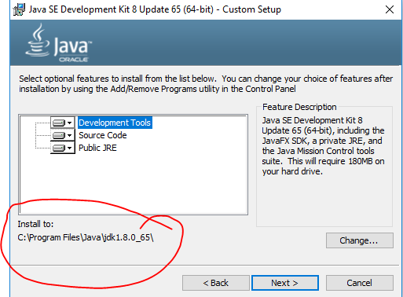
4.you can change the directory whre jdk file to be installed or click next

5.you can change the directory where jre file have to installed or click next
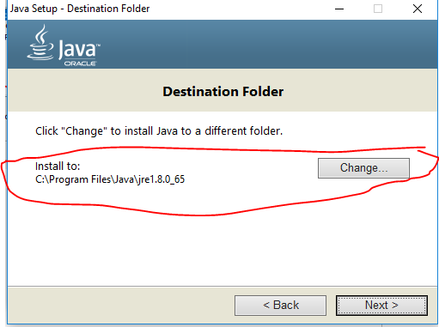
6. click “close” ,installation successful
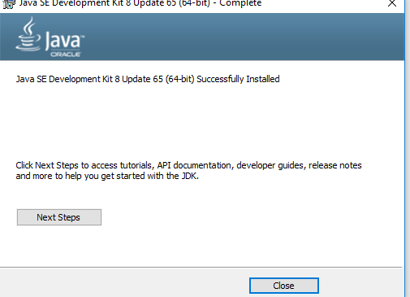
7.set an environment variable
go to the environment variable by right clicking “this pc” ------->properties------>
advanced system settings------->
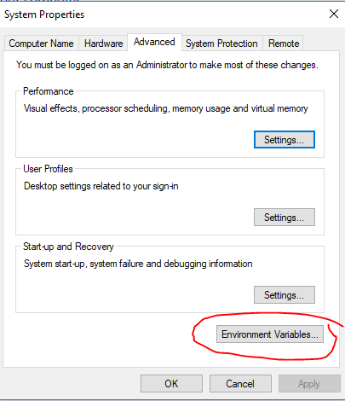

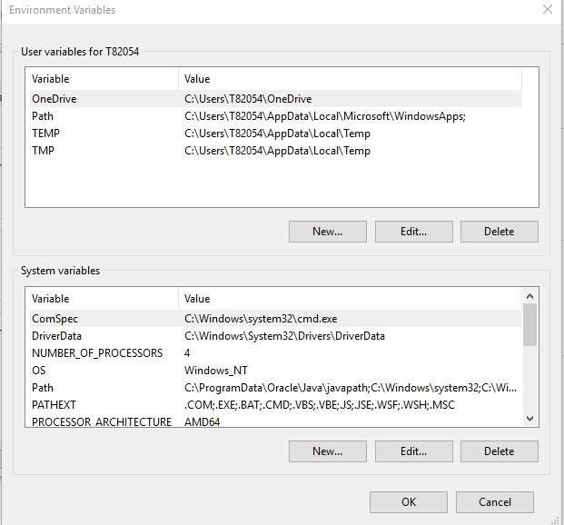
8.click new in “User variables for T82054” and give

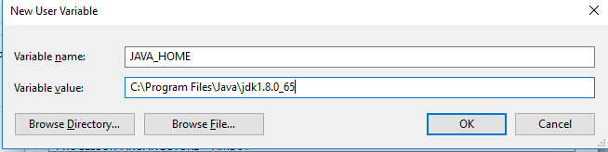
9.click new in “system variables”
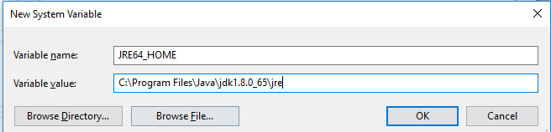
10.click ok and check wheather installed by running command
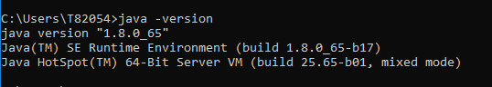
it is succesfully installed

oracle installation:

1.copy Oracle_12_Win64 from 192.168.2.150 and paste in your disk
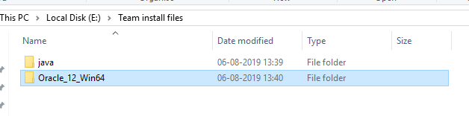
2.run the setup file “run as administrator” inside Oracle_12_Win64
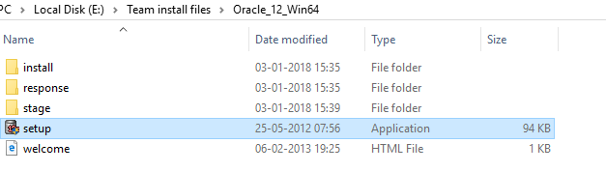
3.click “next”

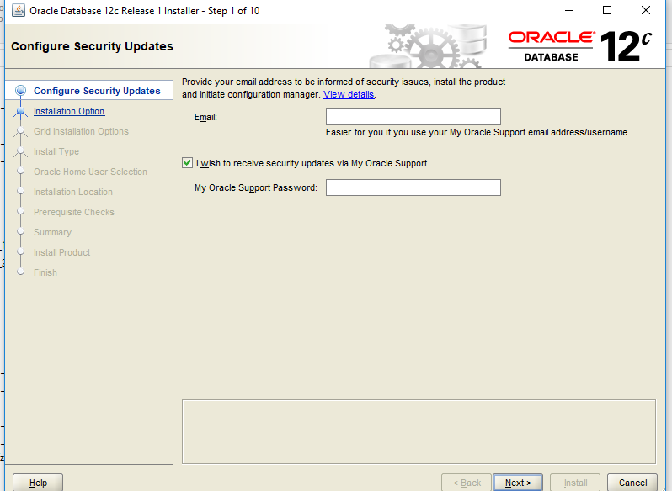
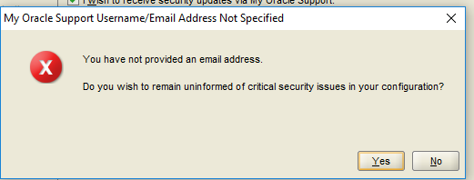
4.press “yes” to the warning

5.click “install database software only” and “next”
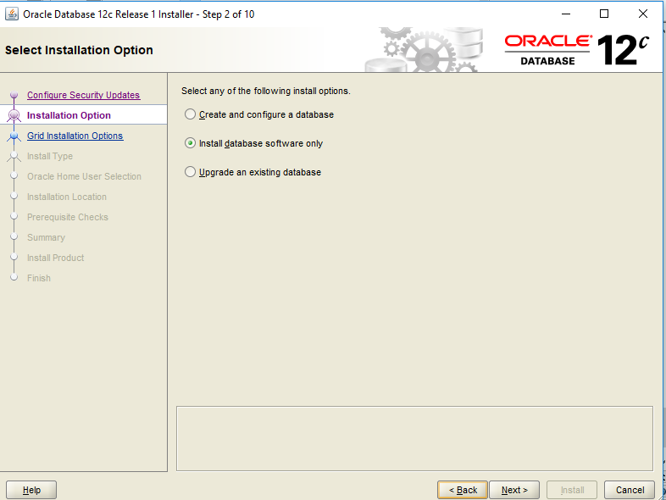
6.click on “single instance database installation” and “next”

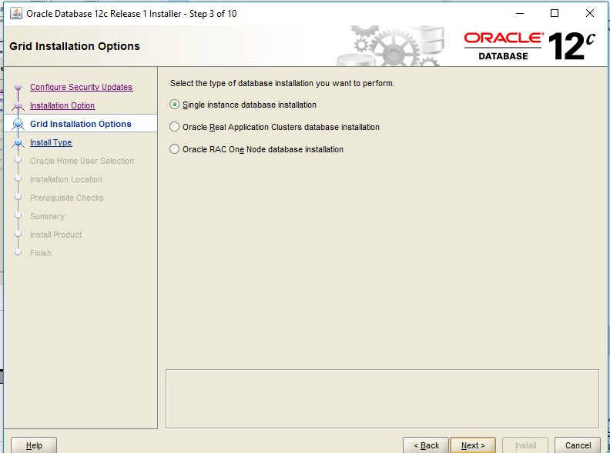
7.click “next”
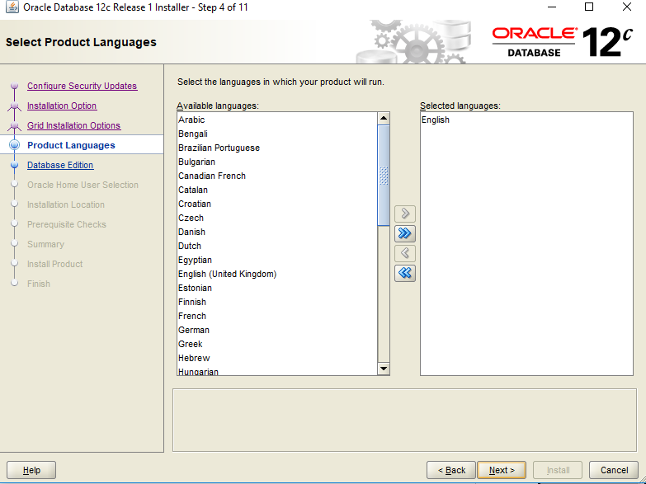
8.click “next”
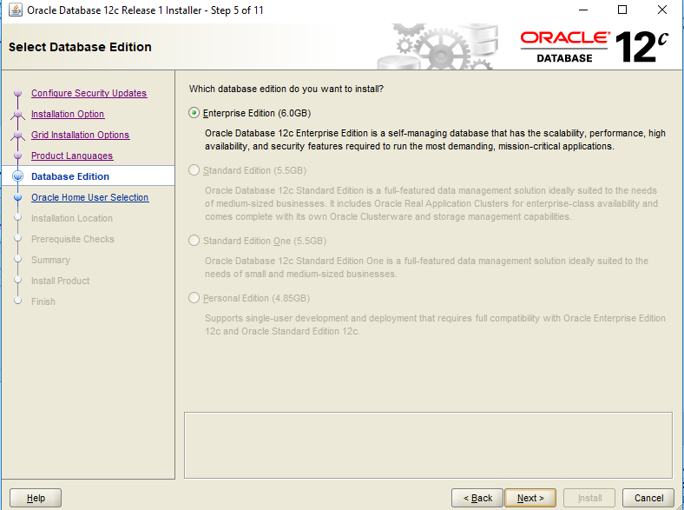
9.click on “use windows built in account”
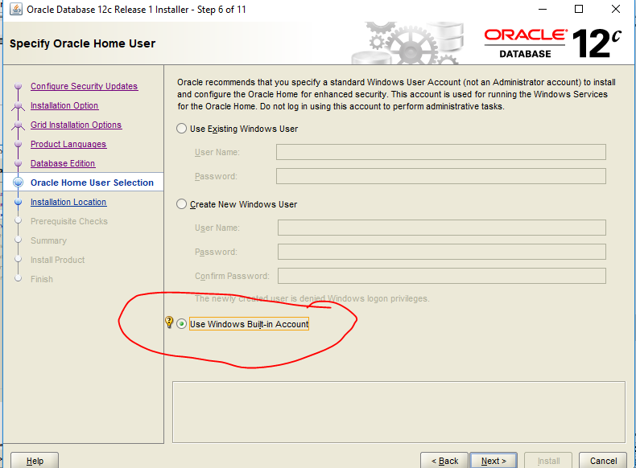
10.click “yes” to the warning

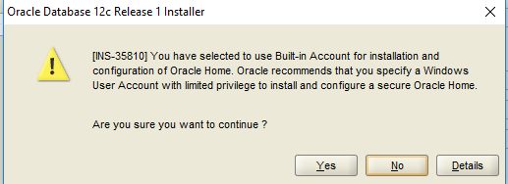
11.give the directory and click next

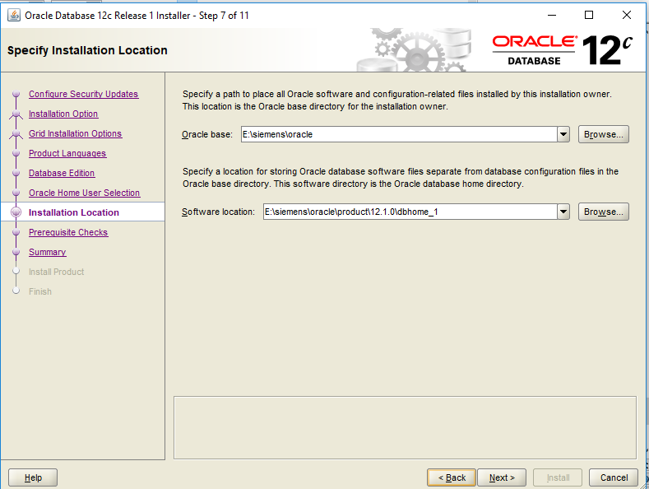

12.click next

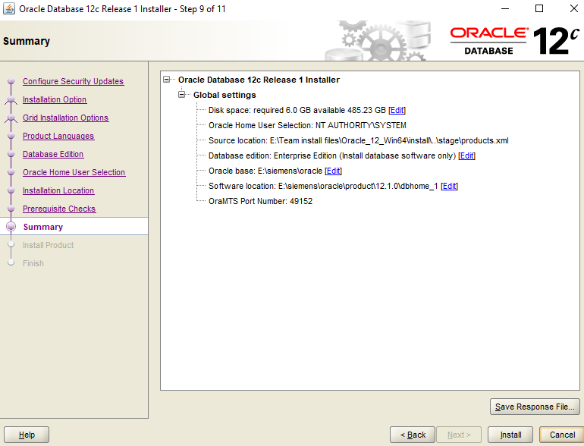
13.click install
14.click close

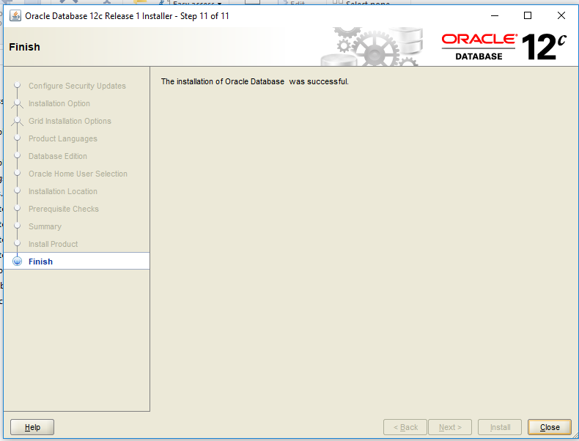
oracle successfully installed.

to get teamcenter oracle in oracle
15.copy all files from \\192.168.2.150\Public\TEAMCENTER_DUMPS\TC_BASE\Tc11.2_64\tc\db_scripts\oracle

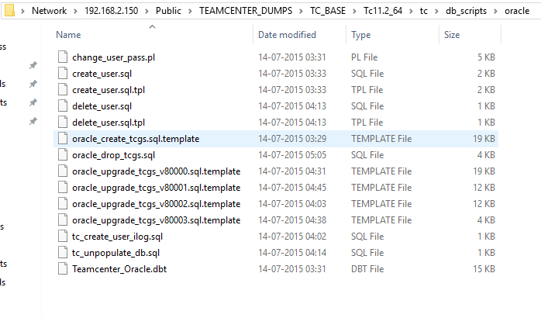

16.paste in E:\siemens\oracle\product\12.1.0\dbhome_1\assistants\dbca\templates
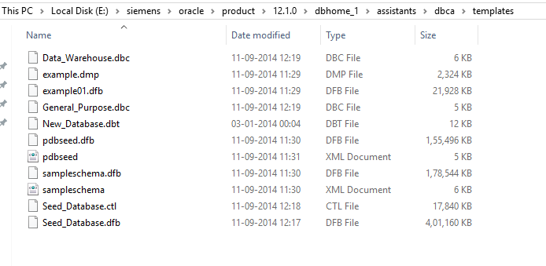

after pasting
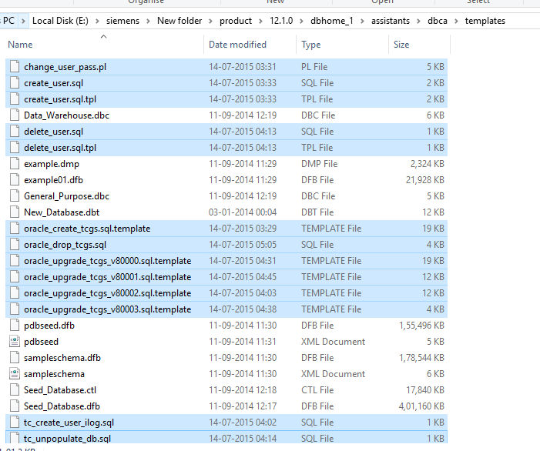
this enable oracle to show the teamcenter oracle in oracle.
17.net configuration assistant

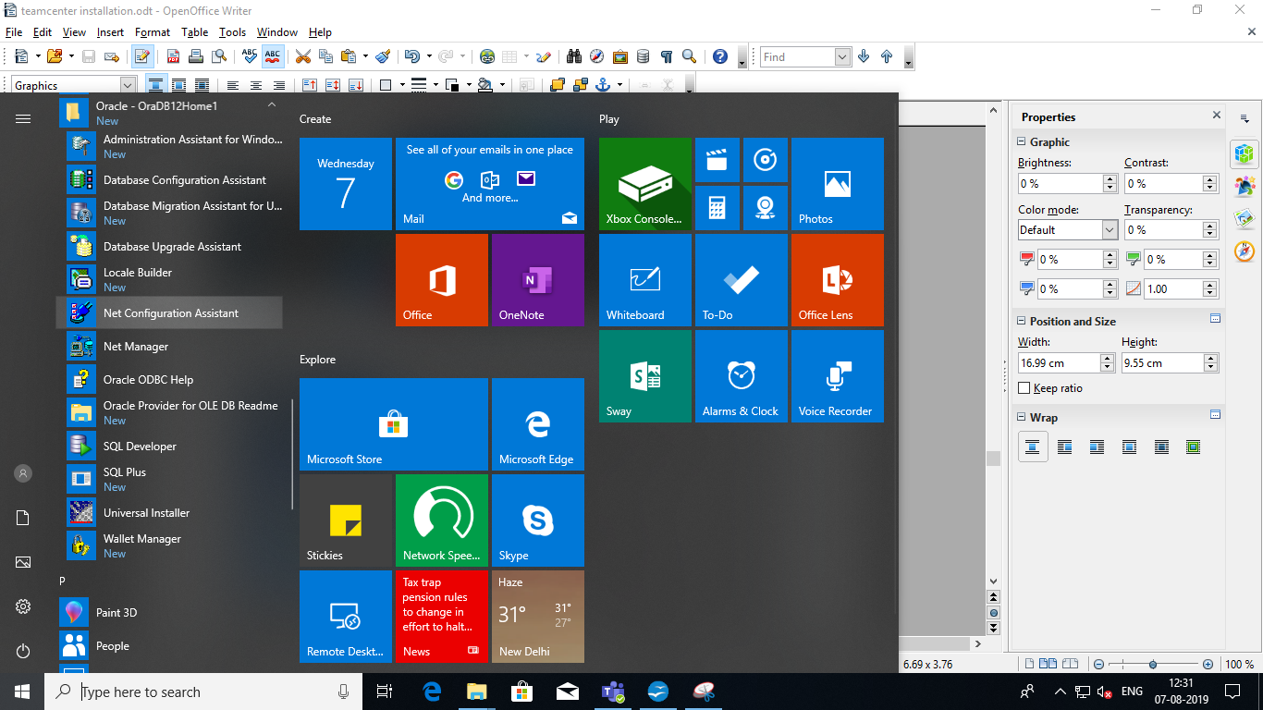

18.run as administrator

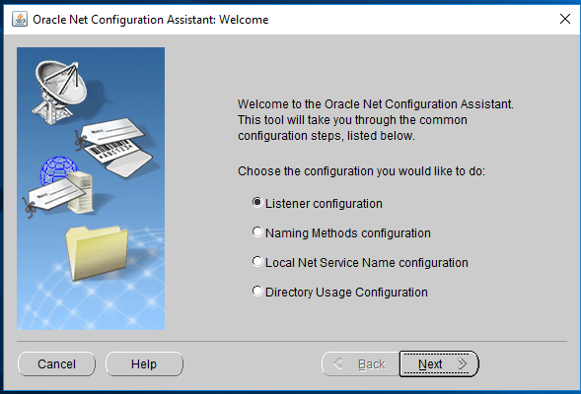

19.click “next”

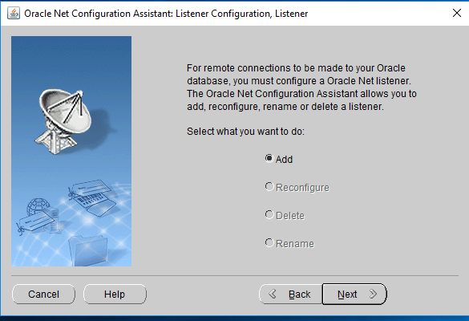
20.give to the listener or click “next”

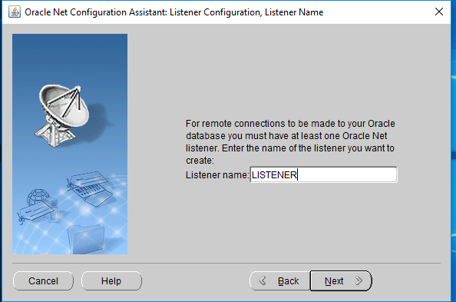
21.click “next”
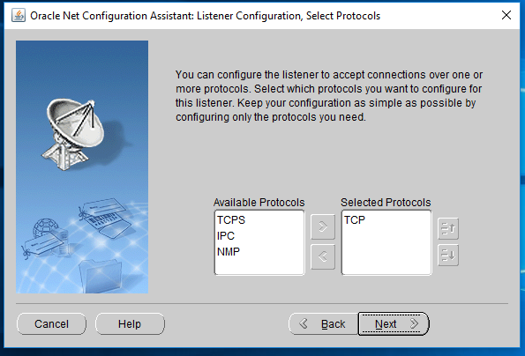
22.click “next”

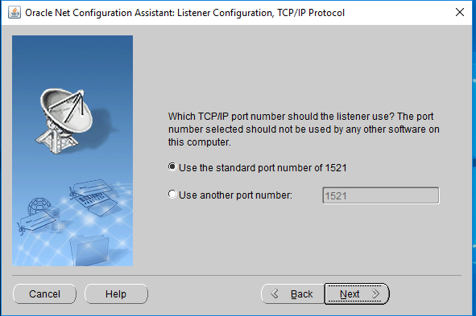
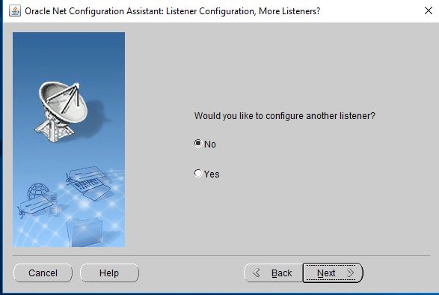
23.click “next”

24.click “next”
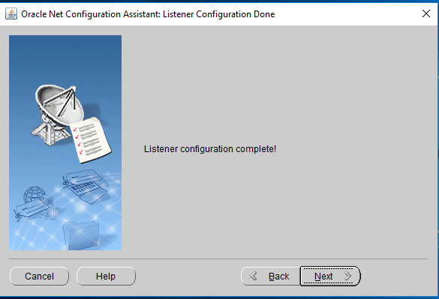

listener configuration completed.

25.database configuration assistant
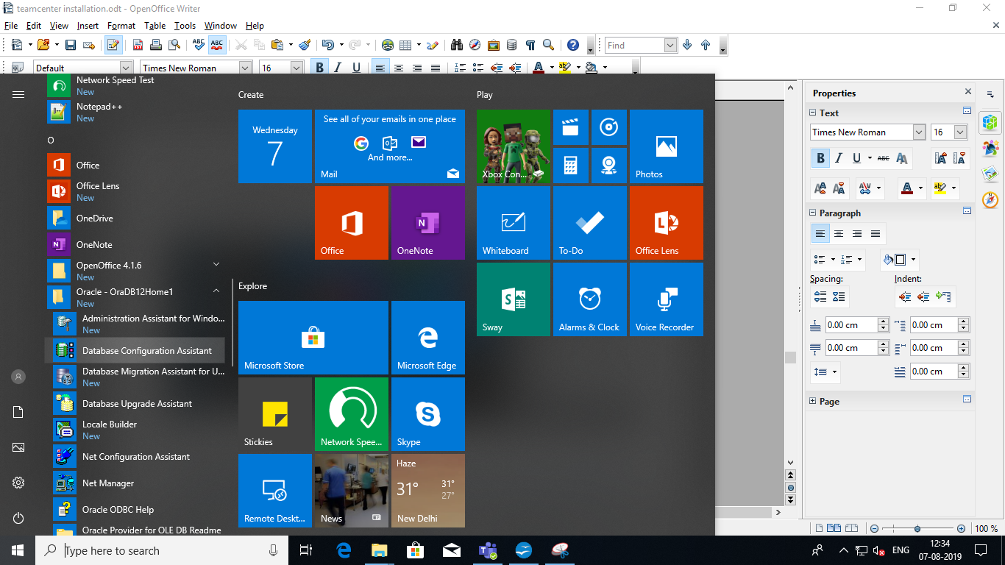

25.right click the “database configuration assistant” and run as adminstrator
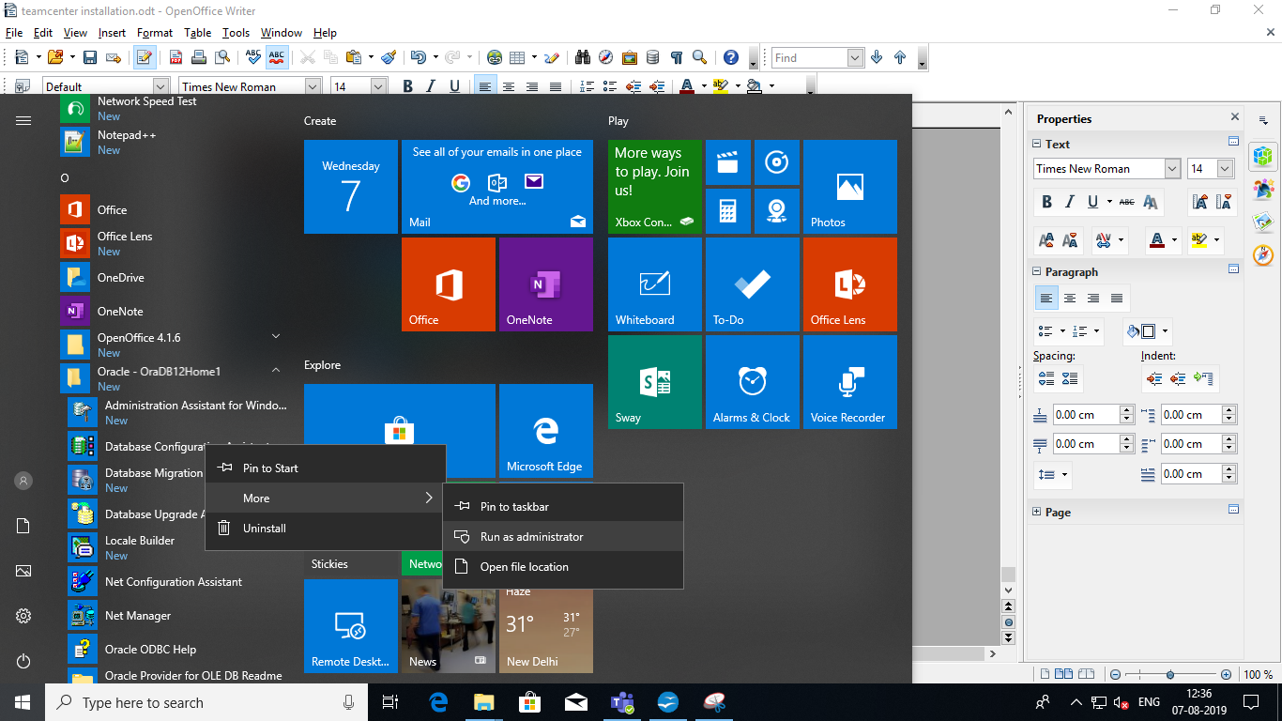
26.click “create database” and click “next”

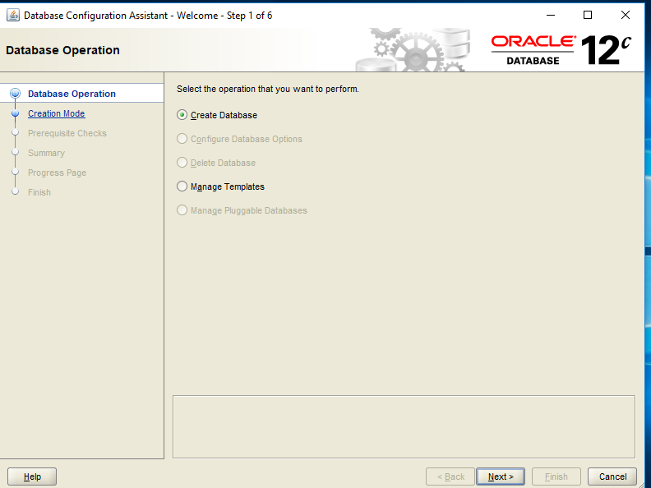
27.click “advanced” and click “next”

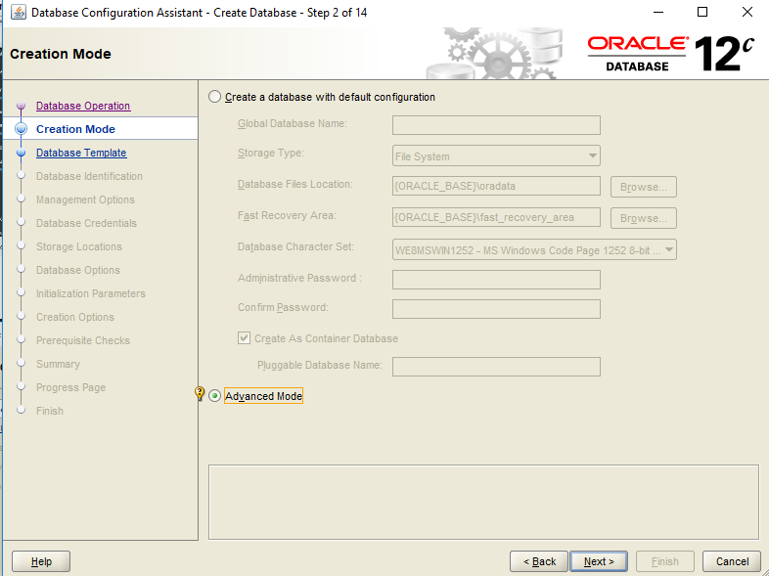
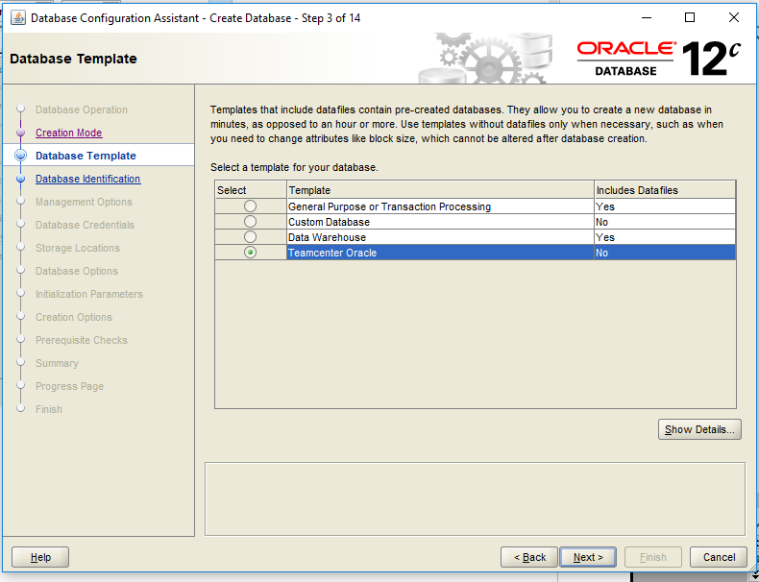
28.click “Teamcenter oracle”

29.give global database name (i.e, TC11) this is database name or instance name.
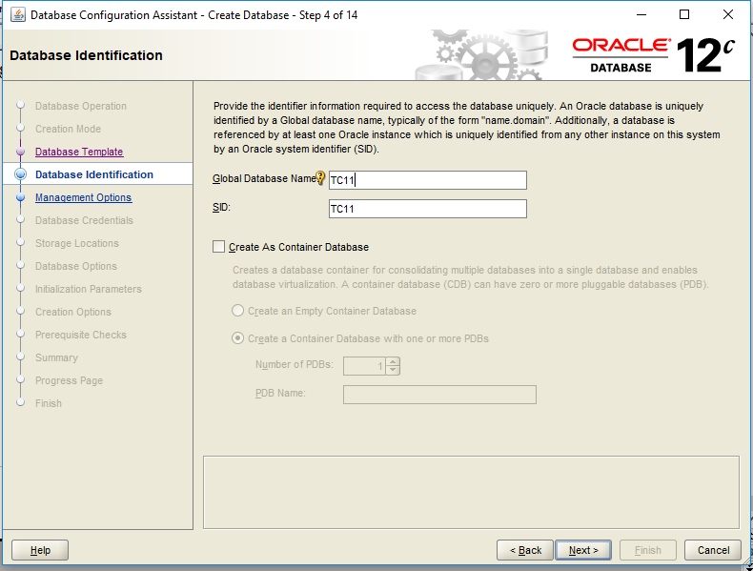
30.click “next”

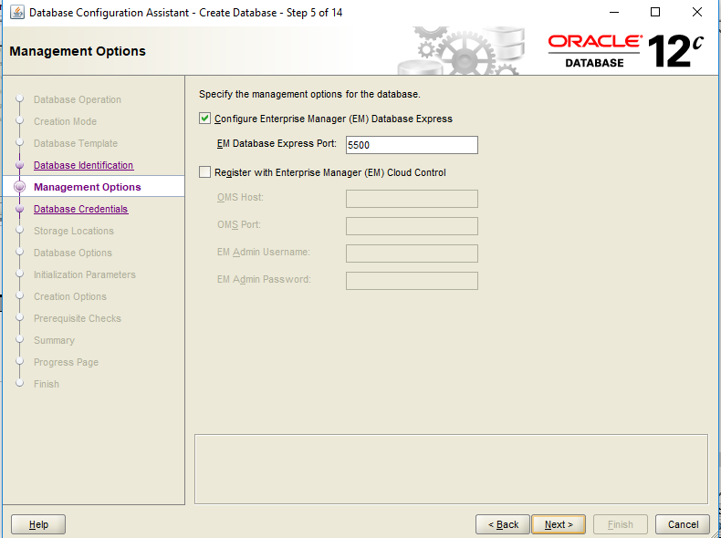
- click “administrator password” set password as[infodba] and conform
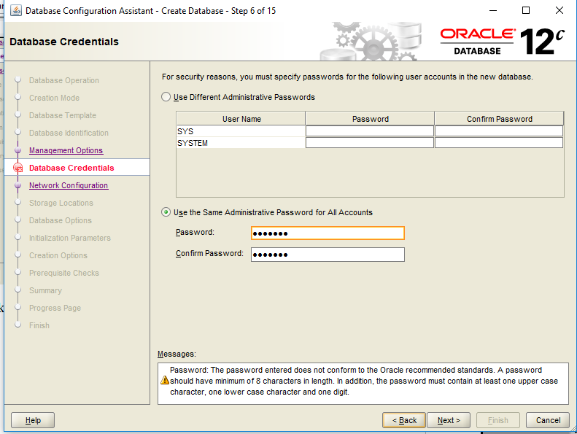
32.click “next”
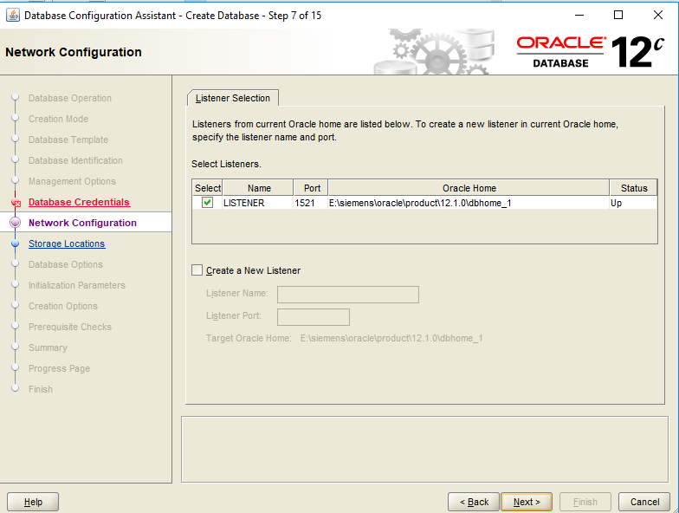
33.click “next”
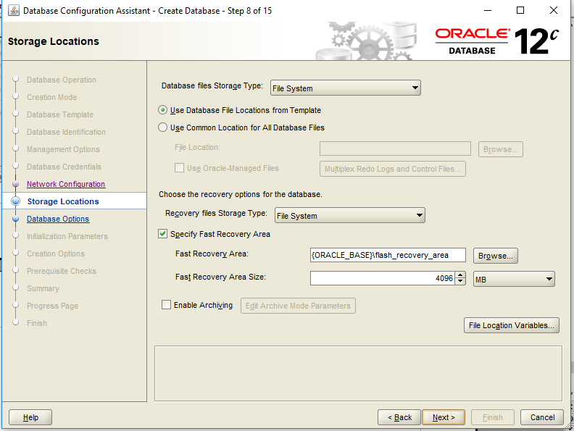
34.click “yes” for warning
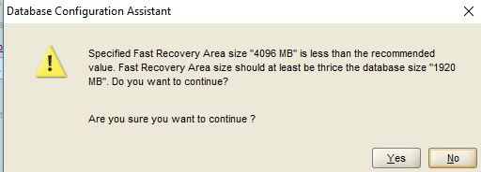

35.click “next”
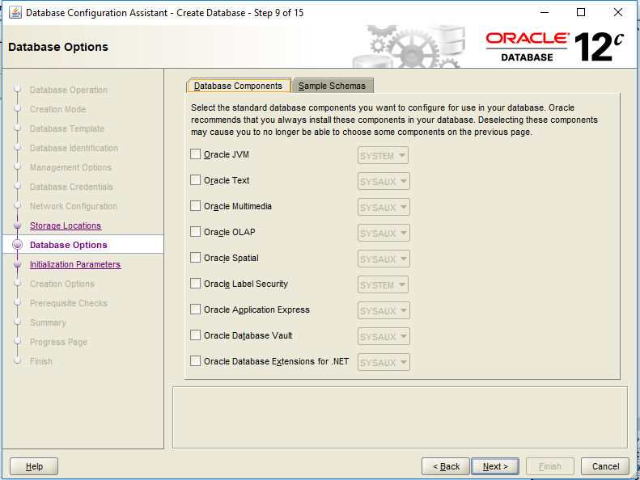
- in “memory tab” in that “typical setting” tick the “use automatic memory mangement”

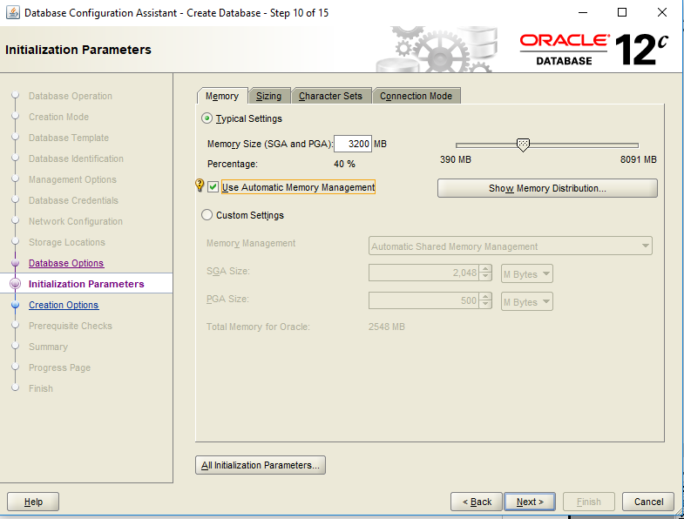

37.in “character set” tab
- tick the use “ use unicode”
- in “National character set” give “ UTF8-U.................”
- in “Default language” give “English”
- in “Default territory” give “India” and click next.

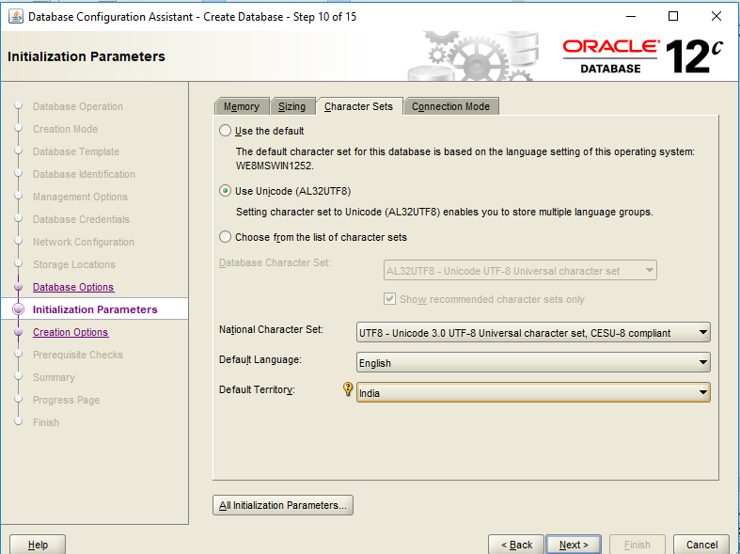
38.click “next”
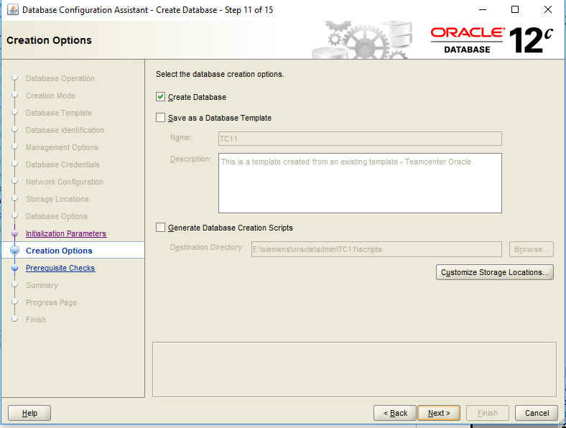
39.click “next”
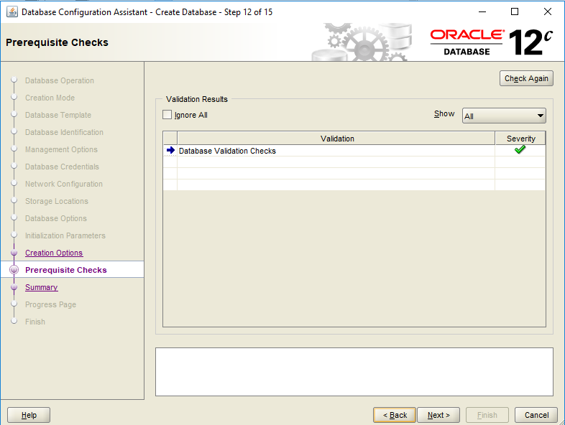

40.click “next”

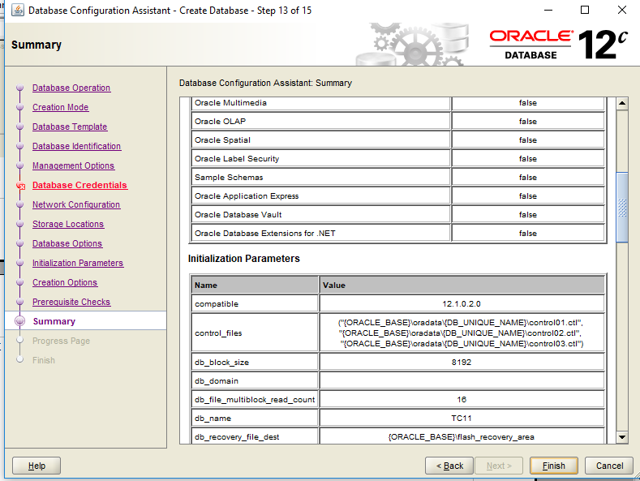
41.click “finish”

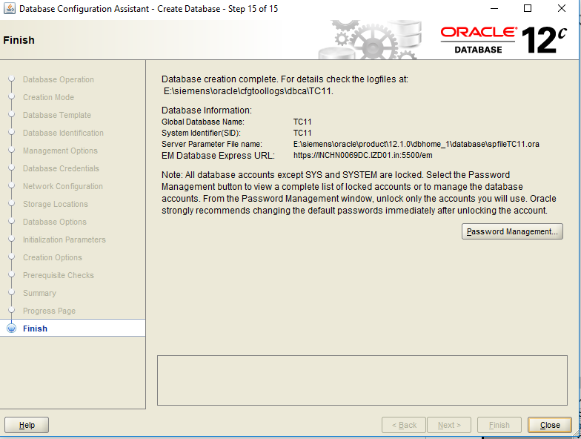
42.click on password management
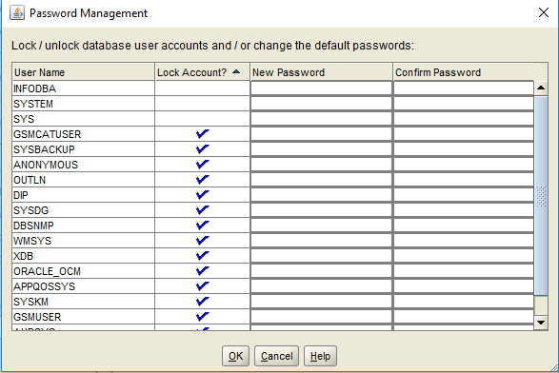
43.give password for all
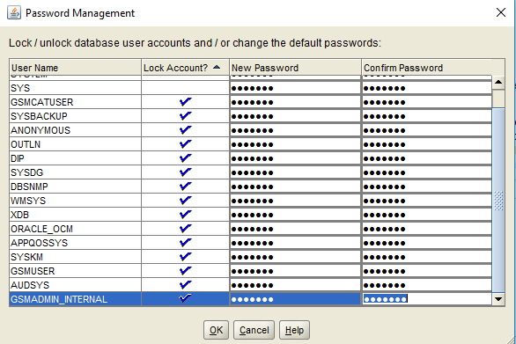
44.click “ok”
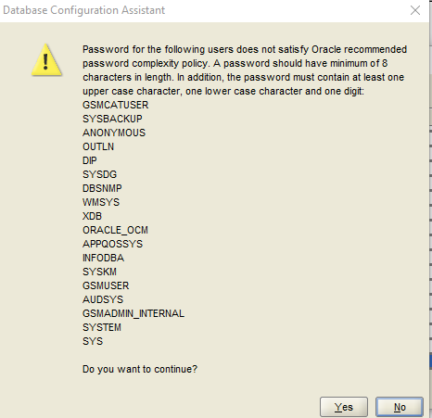
- click “yes”

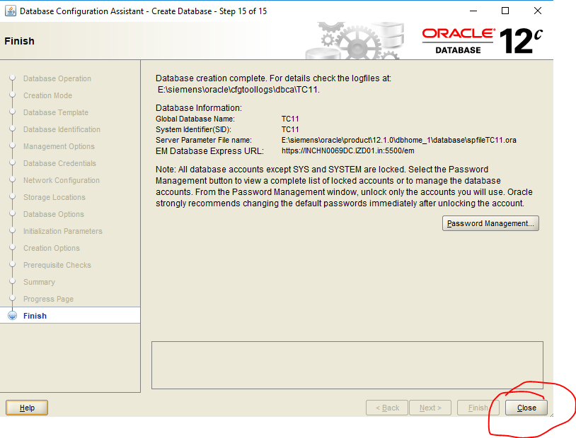
oracle with teamcener is over.

To check oracle is installed or not:
in command prompt
1.run sqlplus /nolog
2.connect infodba/infodba@TC11
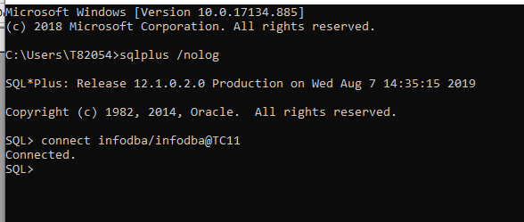
Teamcenter installation:

1.click region in search and verify it have English(india)
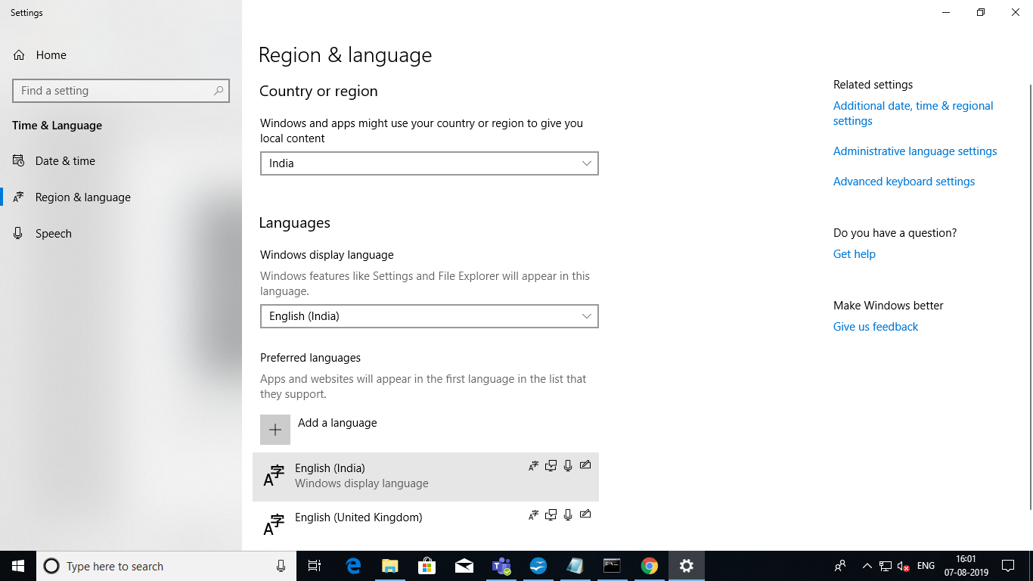

2.run “tem.bat” as run as administrator in E:\Team install files\Teamcenter\Tc11.2_64
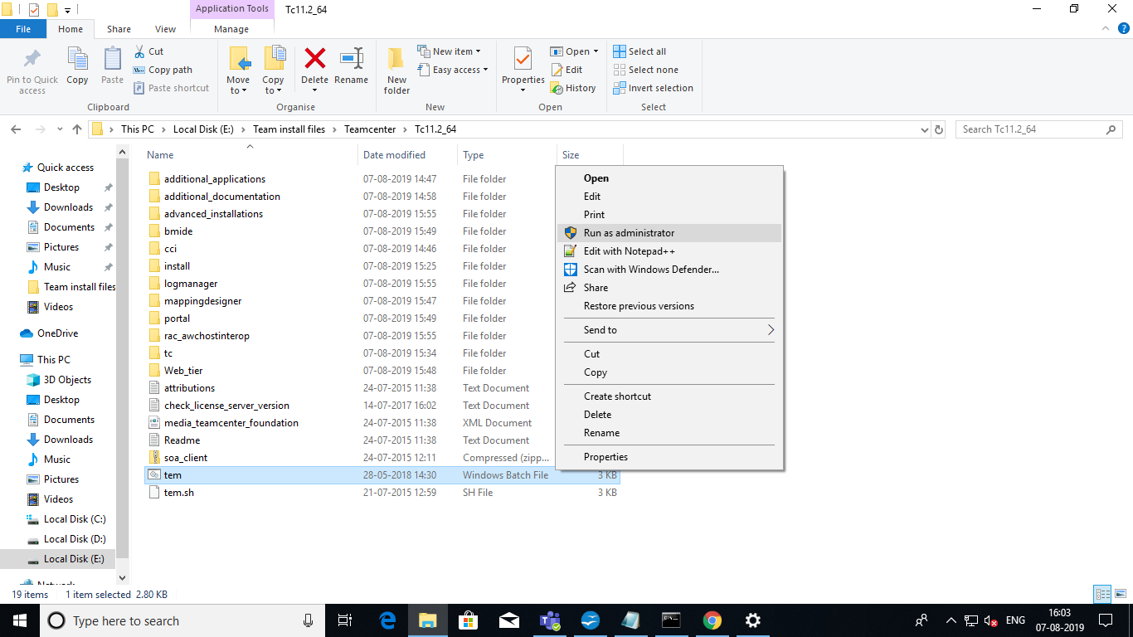
3.click “ok”

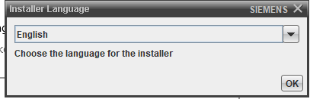

4.click “next”
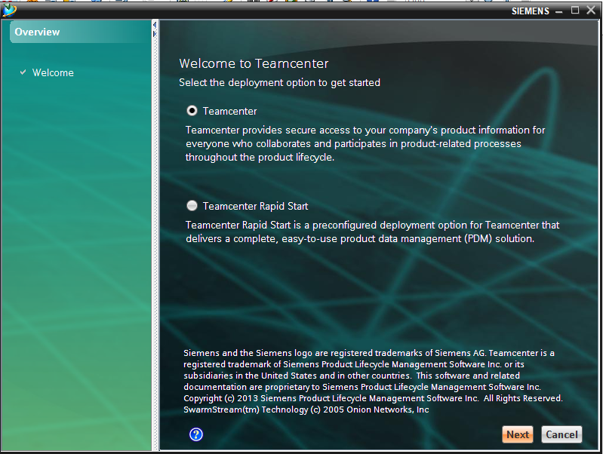
5.click “install”

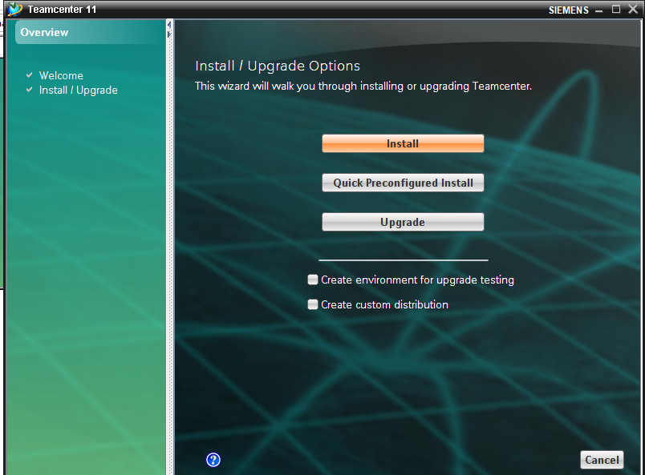
6.click “next”

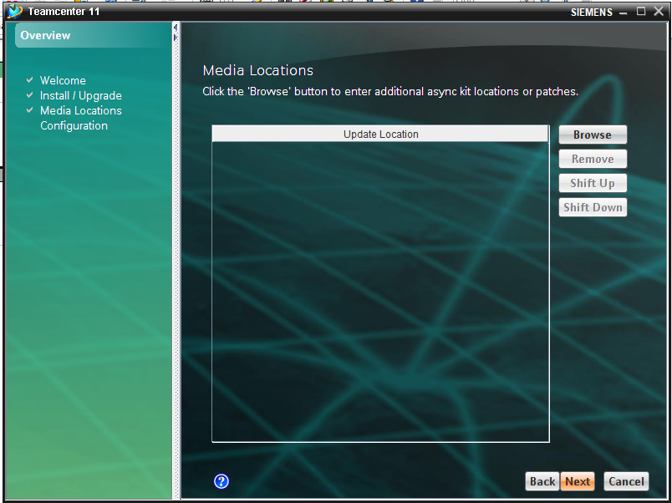
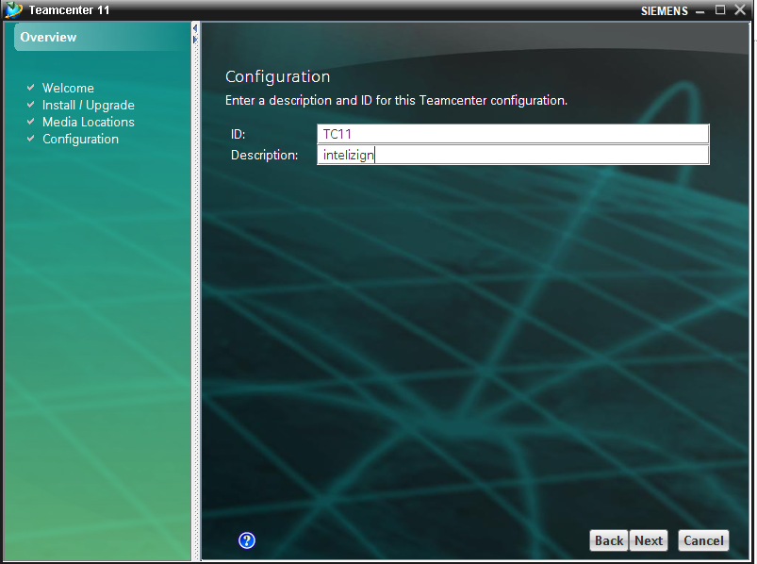
7.change ID and Description as TC11 and Intelizign

8.tick coperate server ,volume server,rich client 2 server,business modeler IDE and “next”

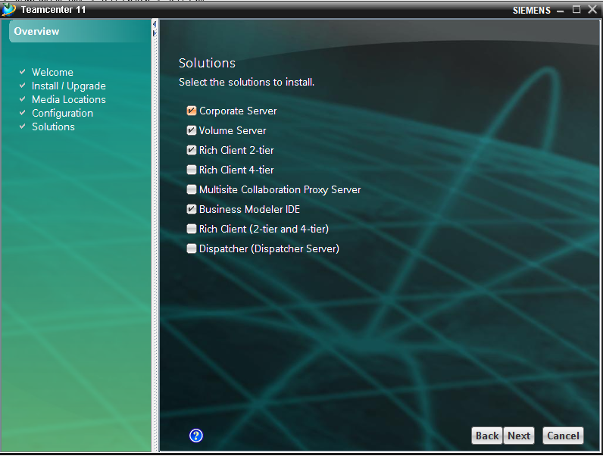
9.specify the path where you want to install teamcenter and “next”.
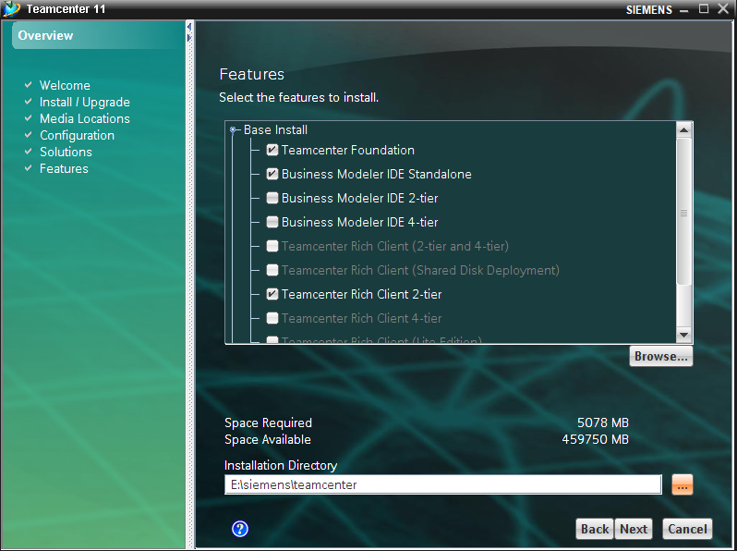
10.give the java jdk path location and click next.
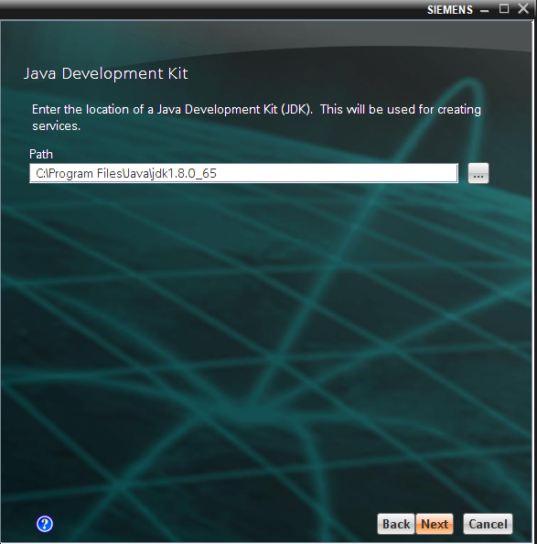
11.click next.

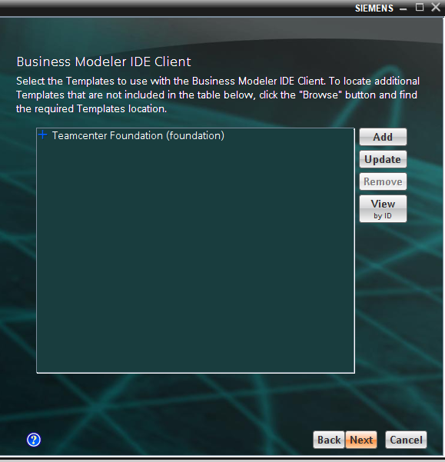

12.remove “_” in FSC ID and “next”.

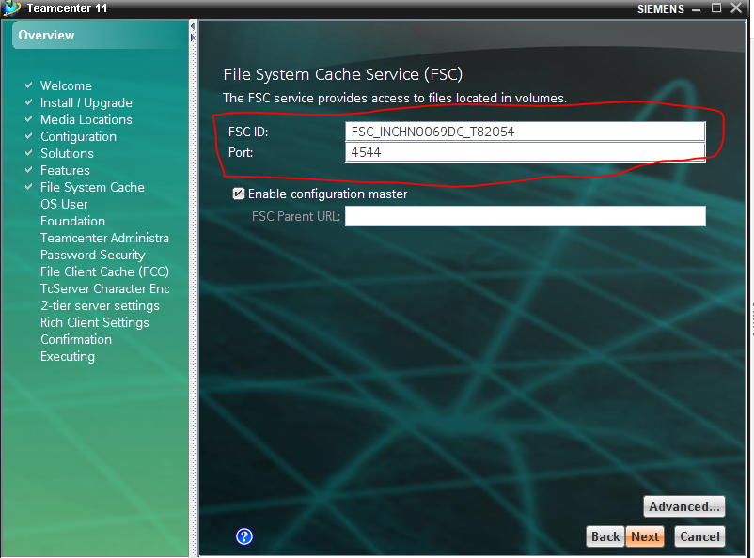
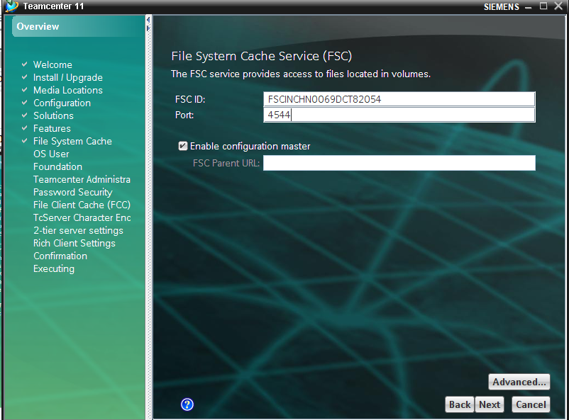

13.give password of system and confirm and click “next”.

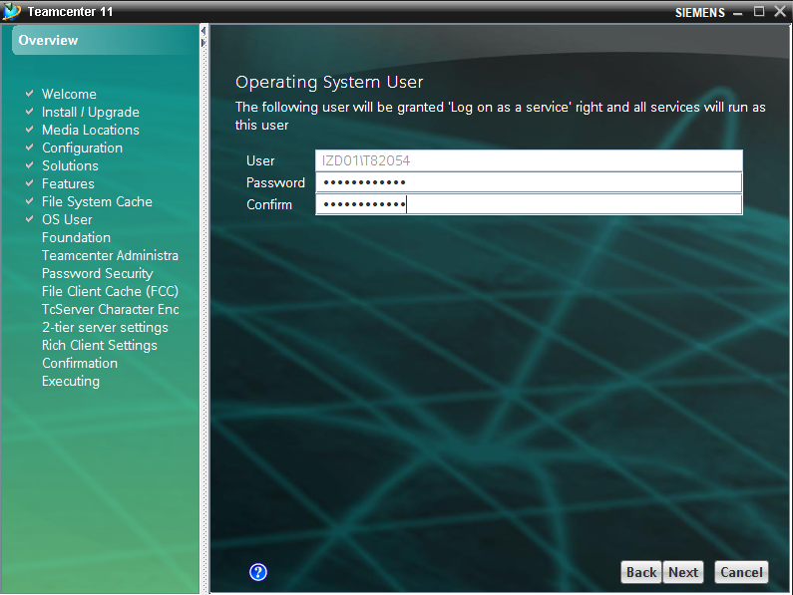
14.tick “populate database ,create new data directory” and click “next”.
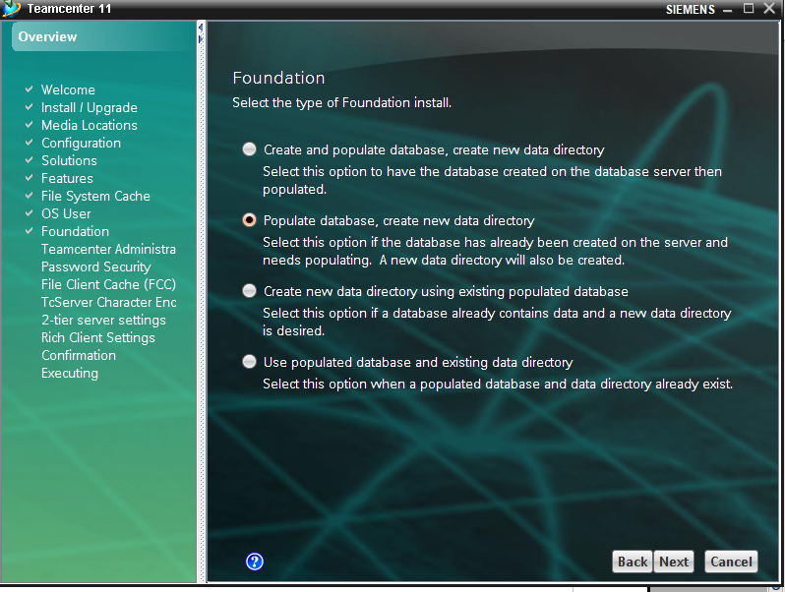
15.
- change database server to oracle
- change services to TC11
- change user to infodba
- change password to infodba(Note:here we are giving database pasword) and click next.

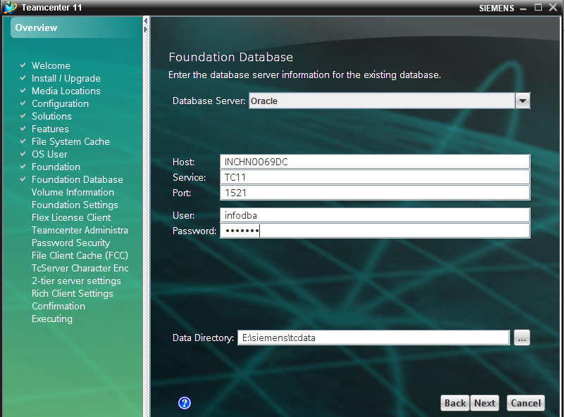
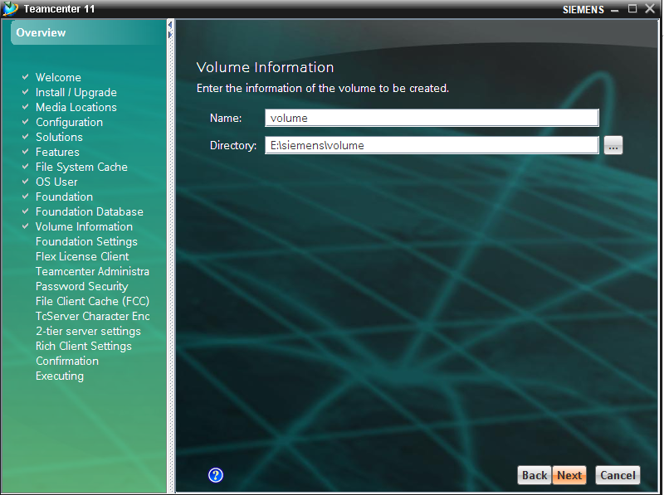
16.click “next”
17.click “next”

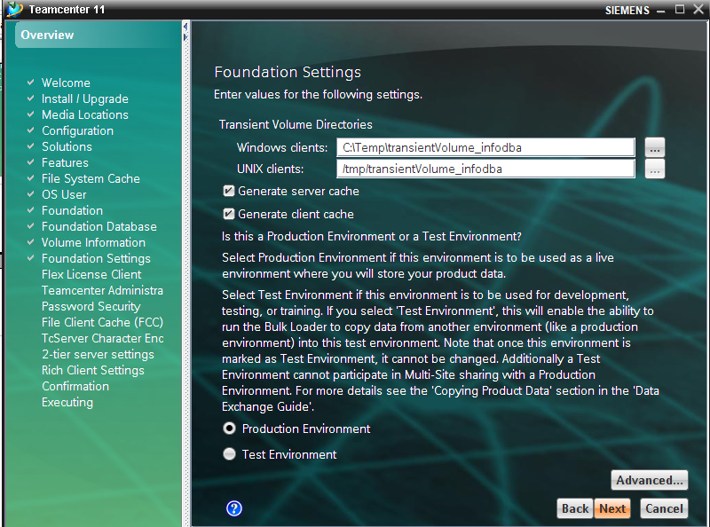
18.here we are specify the license number
click add ----->port =28000
-------->host=192.168.2.15 and click next
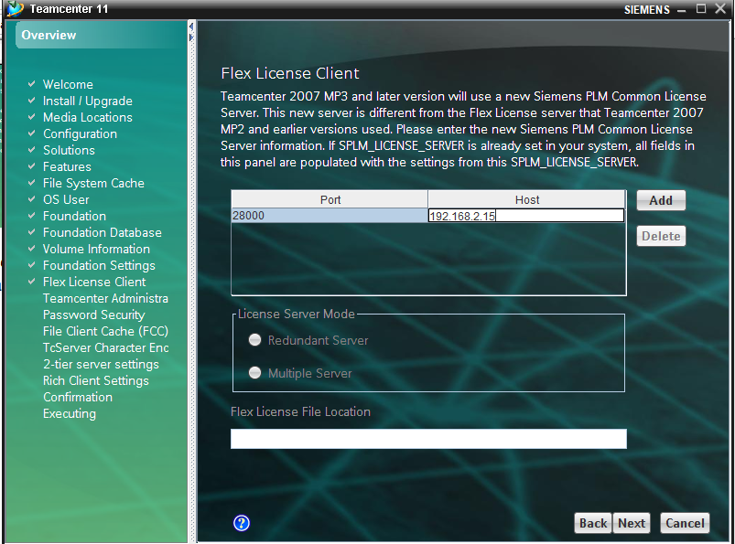
19.click “next”

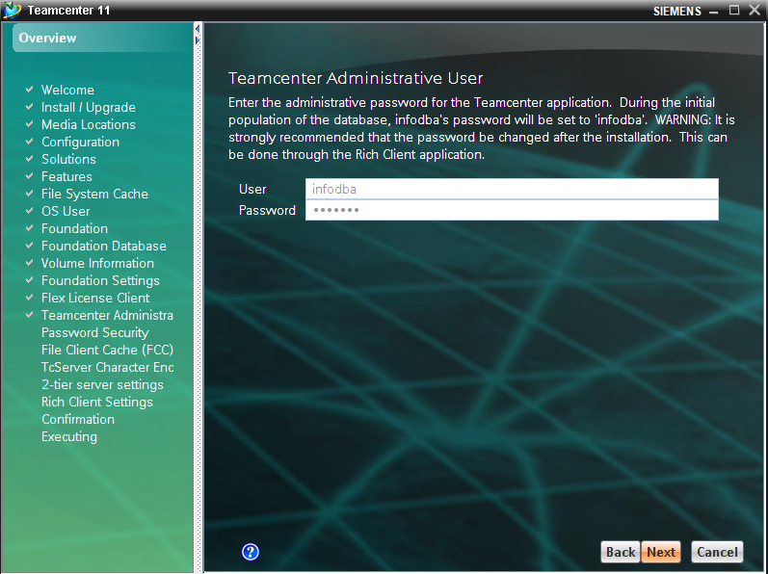
20.click “next”
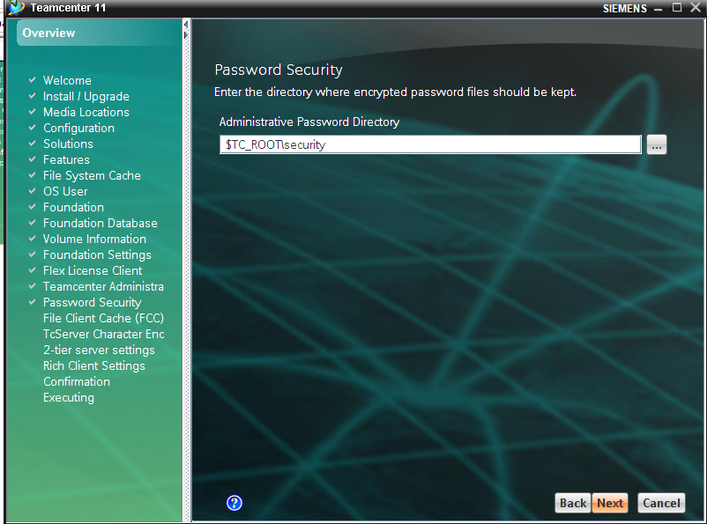
21.click “next”

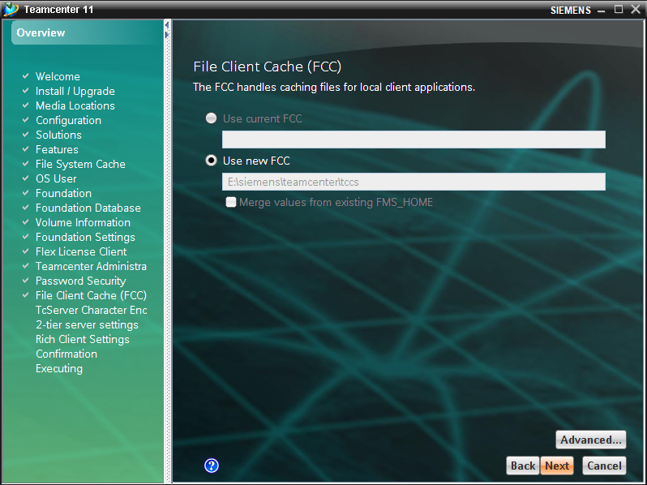
22.click “next”

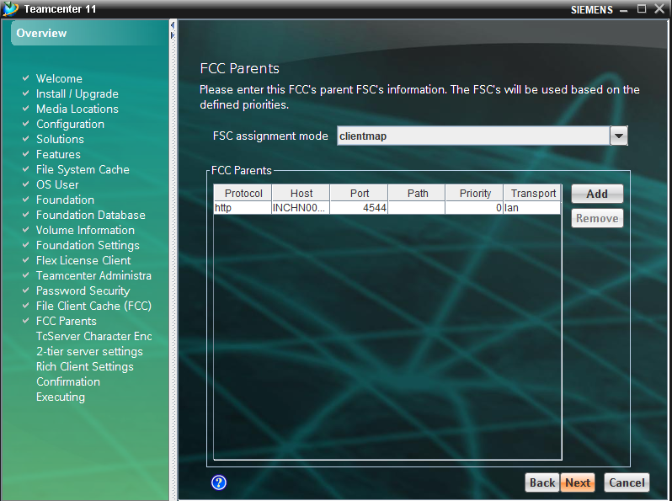
23.in canocial name change to IS08859_1(1st option) and click “next”.

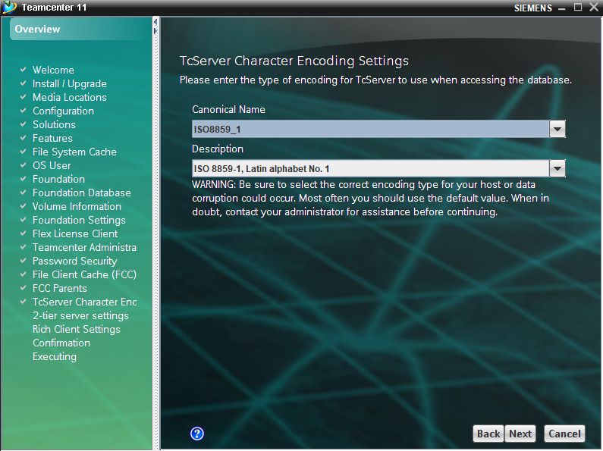
24.click “next”
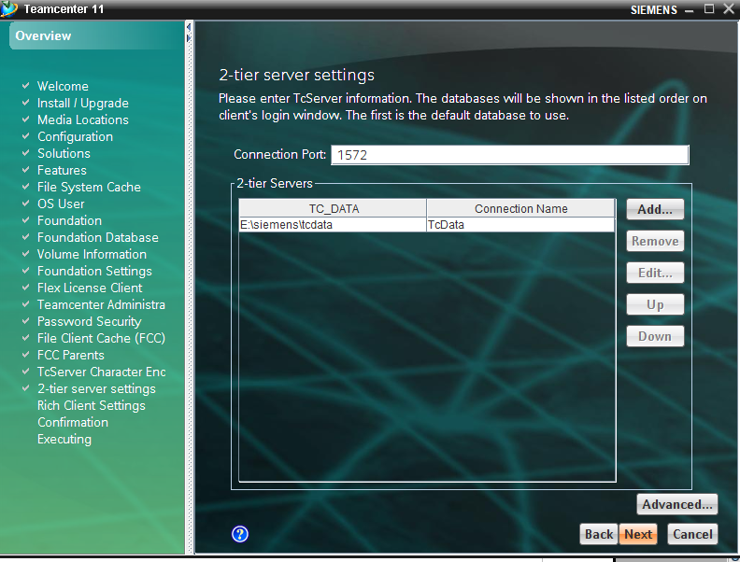
25.click “next”

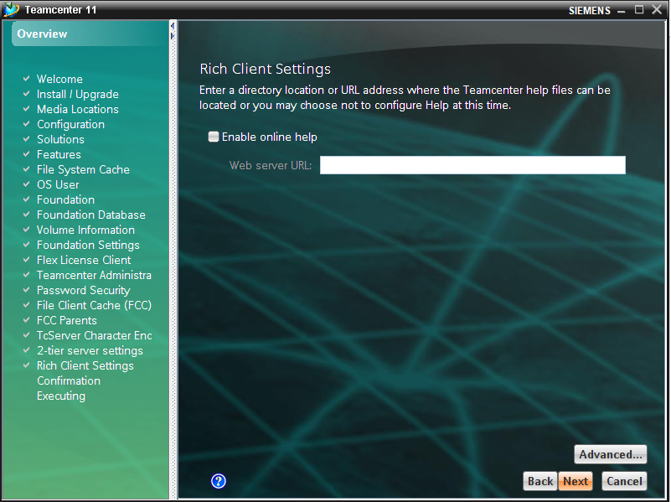
26.click “start”
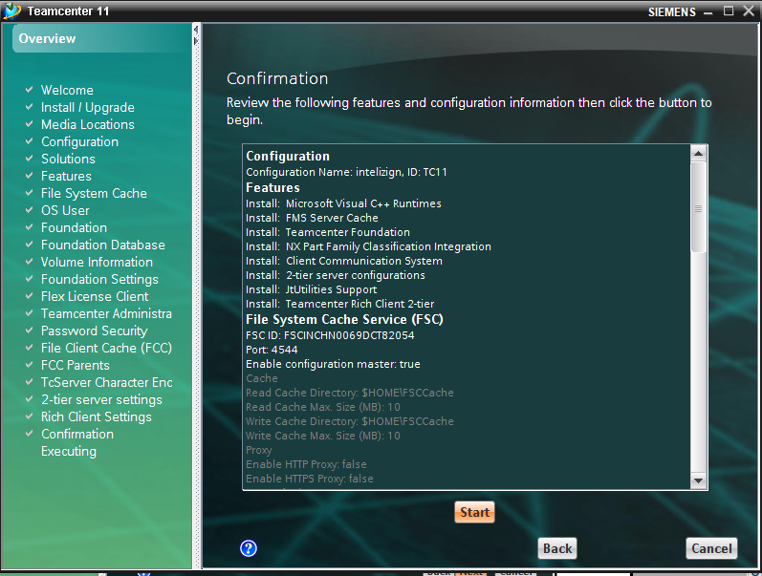
27.teamcenter will be successfully installed.

Installation of bmide for teamcenter 11.2(IF YOU NOT AS SELECTED AS FEATURE WHILE INSTALLATION)

1.run tem.bat as administrator in install files
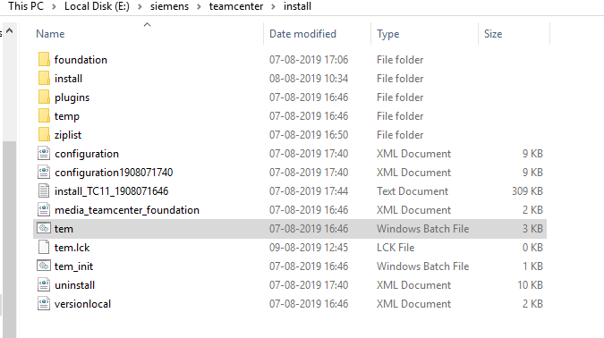

2.click on “configuration manager” and click “next”

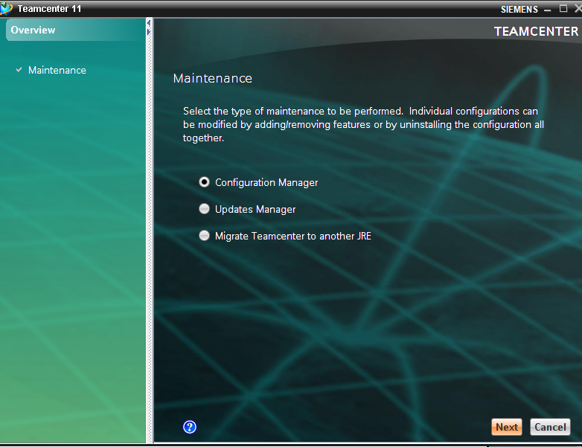

3.click on “perform maintance on exiting configuration” and click “next”
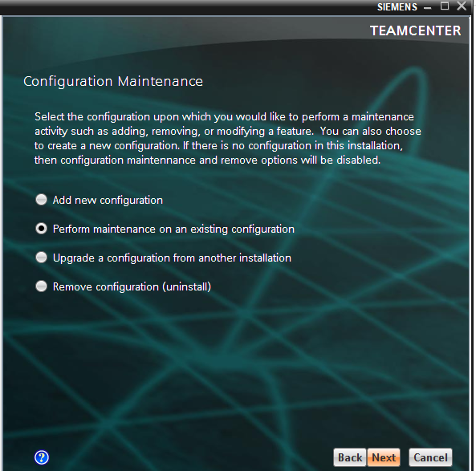

4.click next

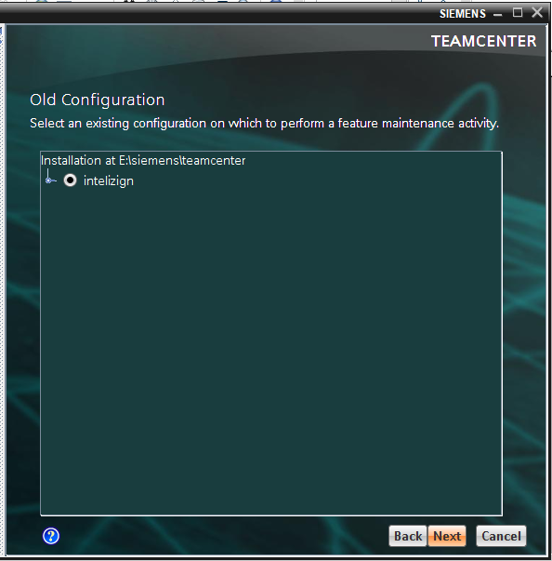
5.click on add/remove features.

5.click on “Business Moduler IDE”
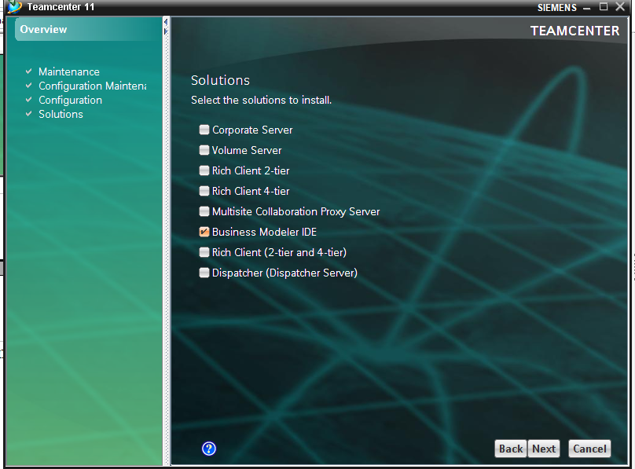

6.give path or click “next”
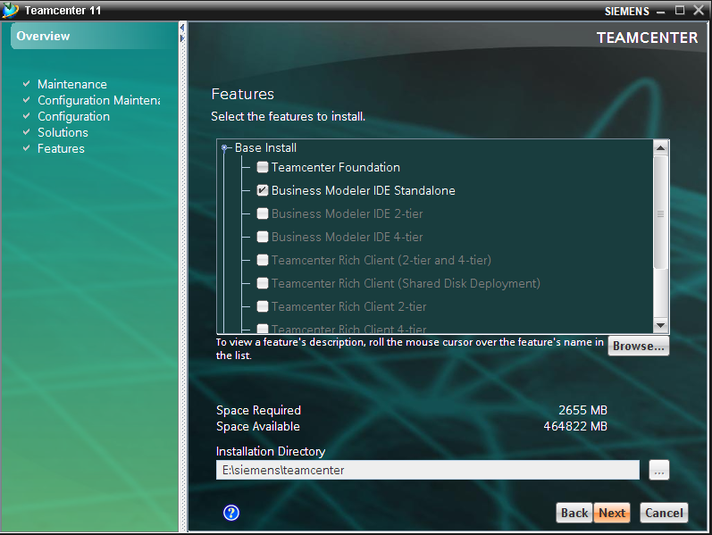
7.give java development kit path in your system
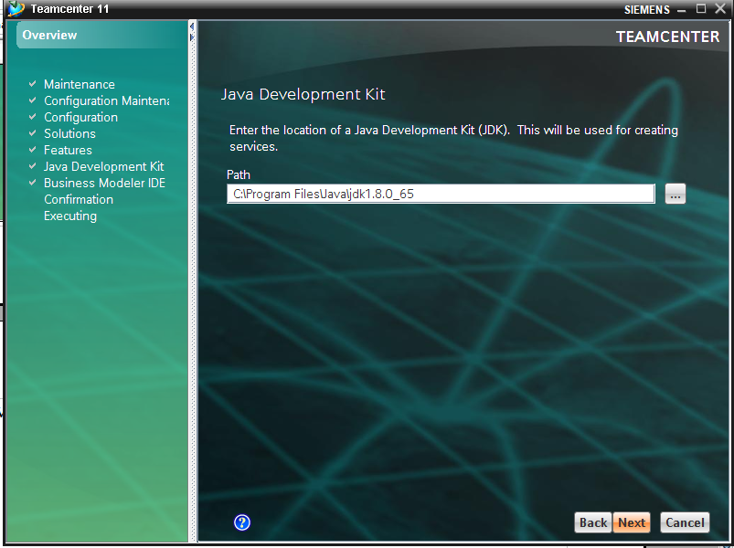
8.click next
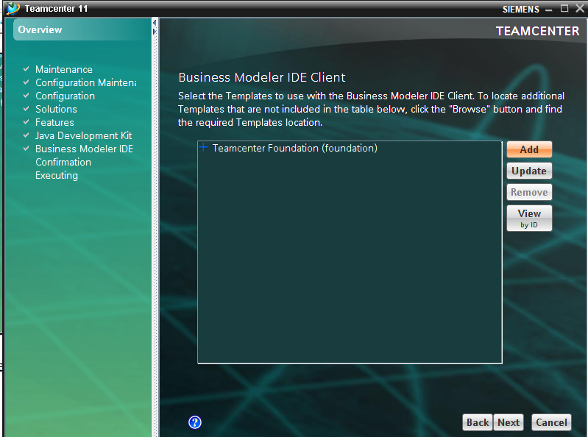

9.click start
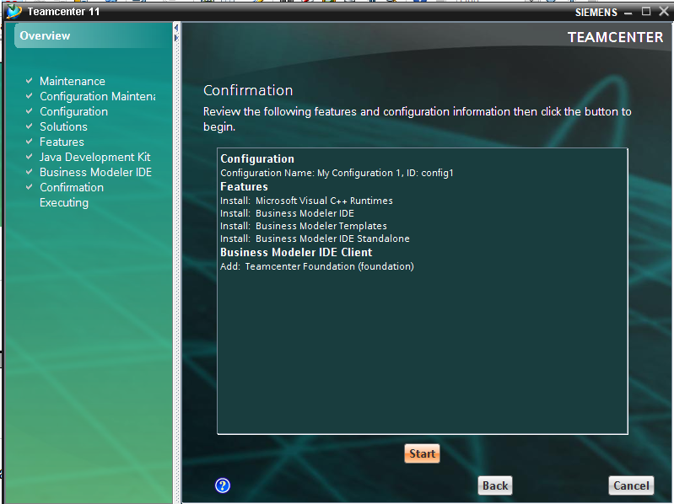

10.installation successful.

How to update teamcenter 11.2 version to 11.5 version?

Step1:copy all the files in “TC11.5.0_patch_3_install folder” to the install folder in teamcenter directory.

1.copy all files in TC11.5.0_patch_3_install
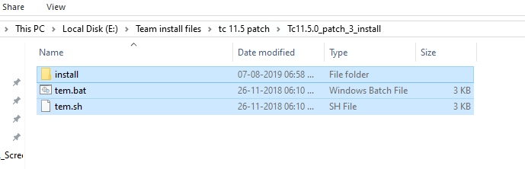
2.paste it in install folder in TCROOT
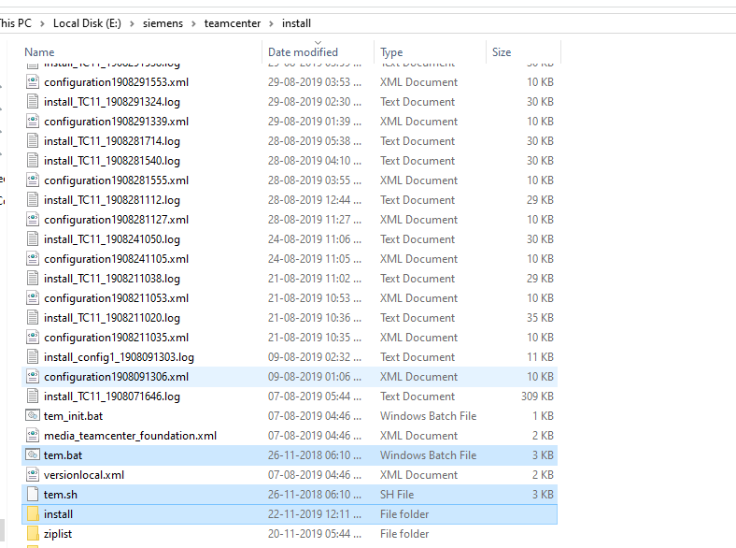

step2:run as administrator “tem.bat” in install folder in TC-root.

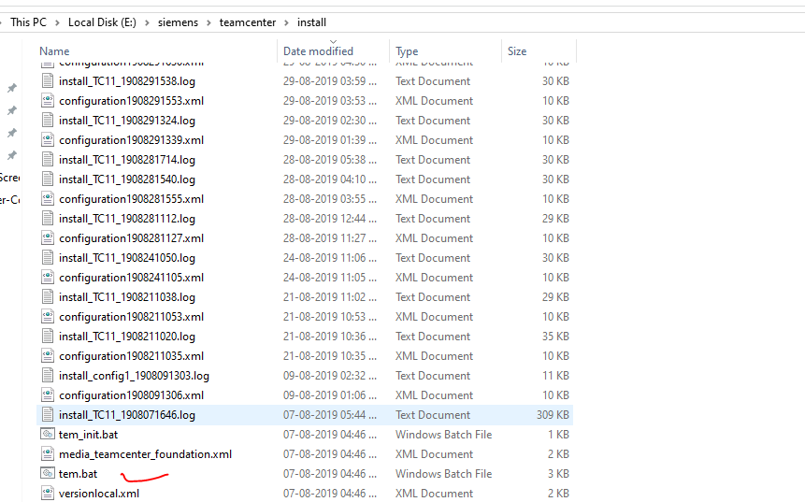

Step3:click on updates manager
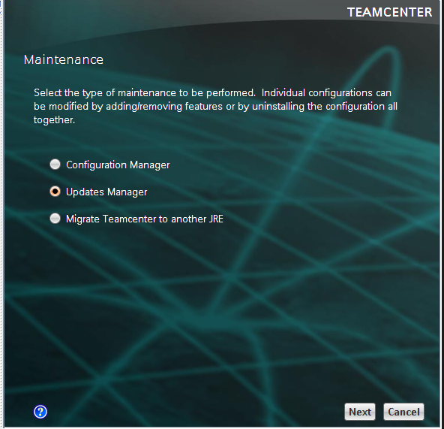

step4:give the update kit location (i.e)patch file of 11.5 teamcenter
E:\Team install files\tc 11.5 patch\Tc11.5.0_patch_3_wntx64\wntx64 and click next

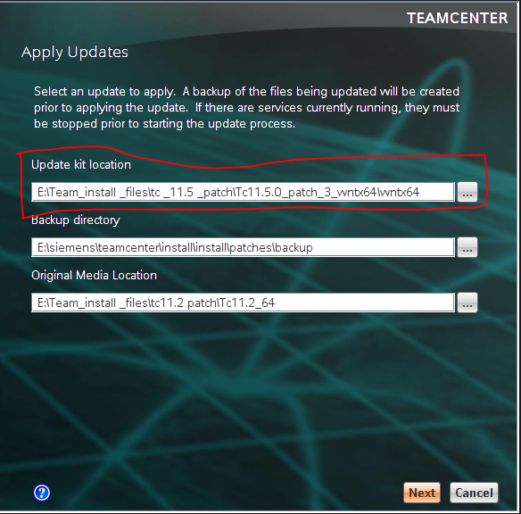

step5:click close for notification and click next.
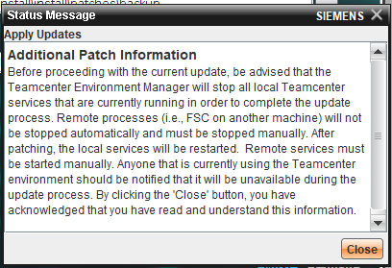
step6:ente windows password.

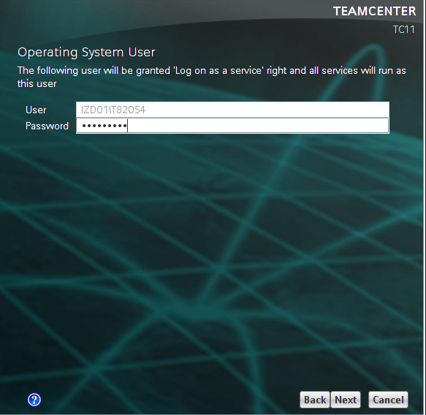

Step7:enter teamcenter password
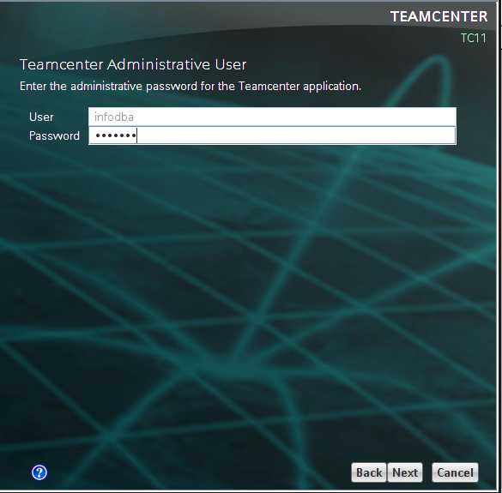

step8:click next.

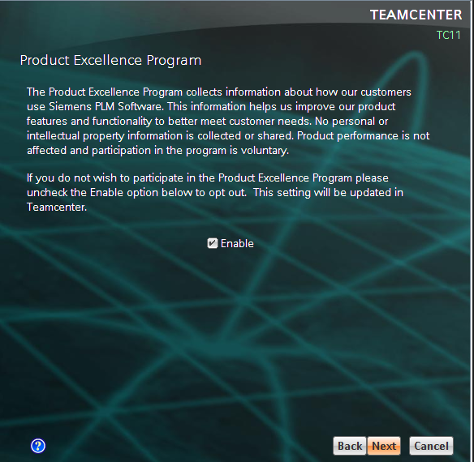

Step9:tick accept data model updates and click next.

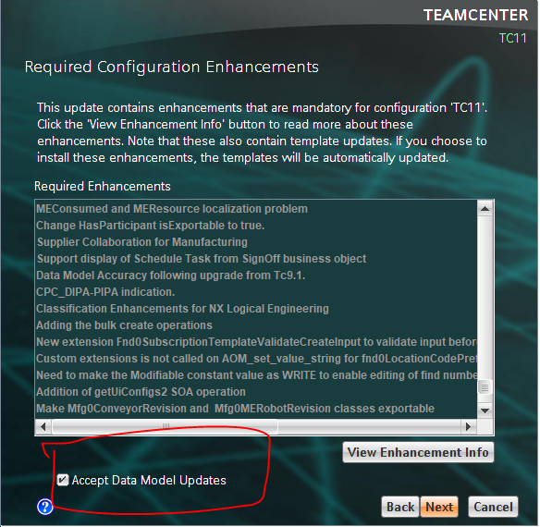

Step10:
1.enter database pasword to the Database user password.

2.tick the “ Use database system user to grant the permission” and in the “system user” ---->system & “system user password”---->(db password)(i.e infodba)
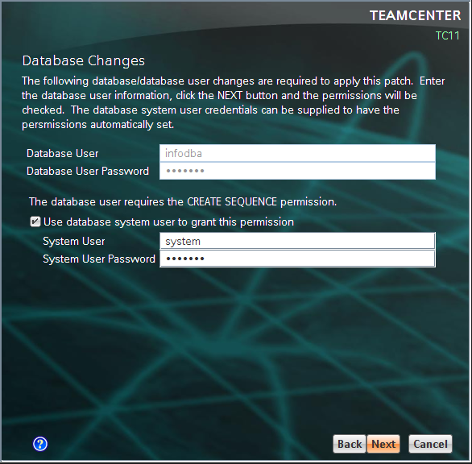

step11.:click next
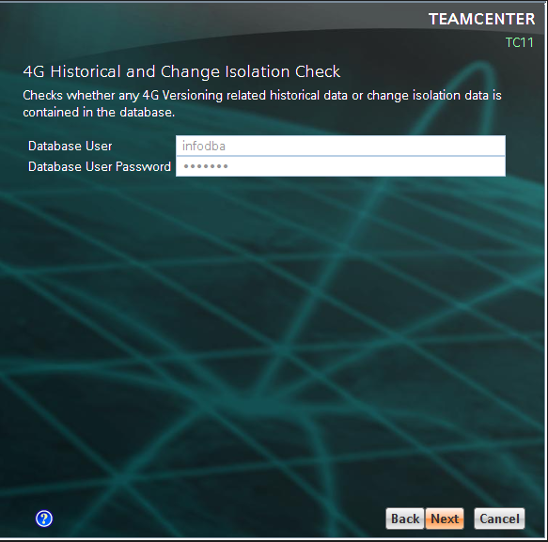

step12:click next
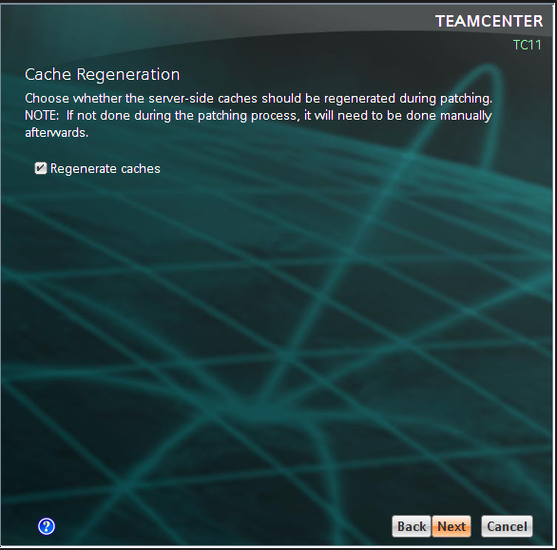

step 13:create a folder for logs in a directory ,browse that directory and click run.
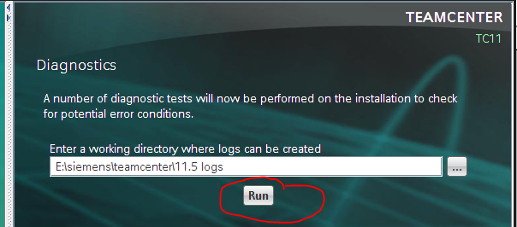
Click ok for dialogue box

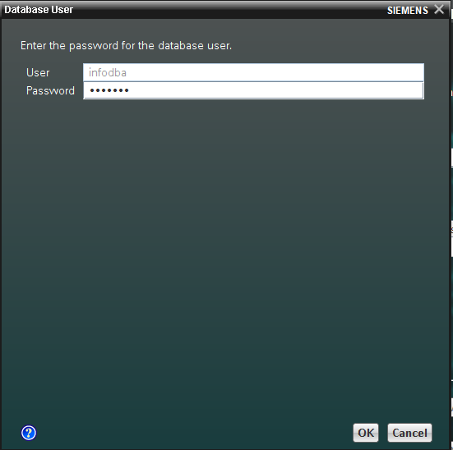

it will generate log file in the directory.

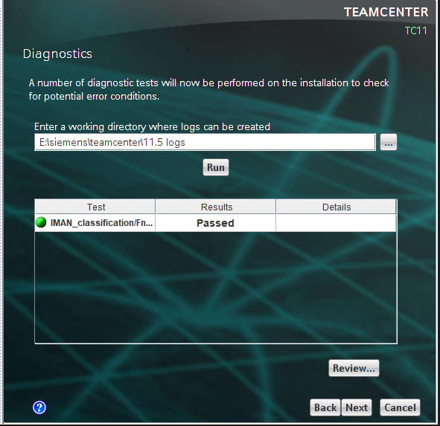

And click next.

Step14:tick accept Data model updates an dclick next.

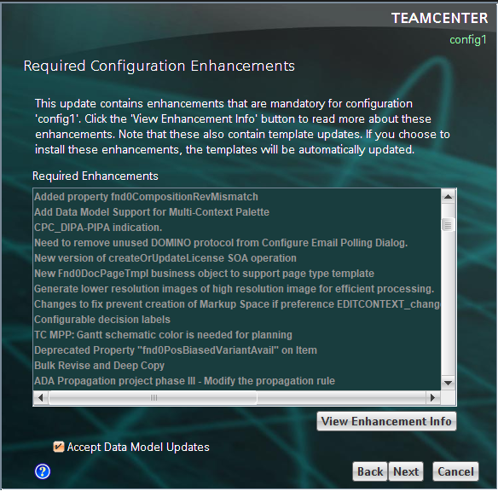
Step15:click start
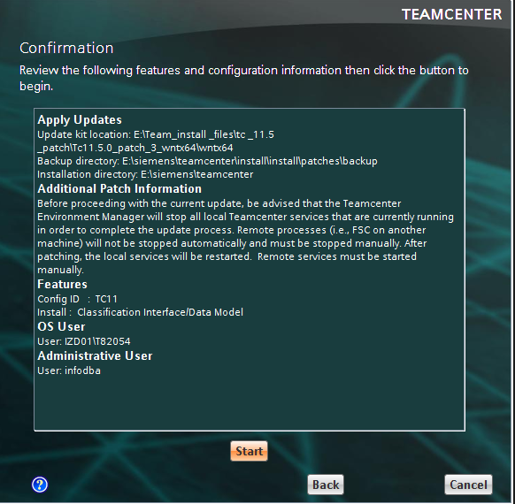

step16:click close
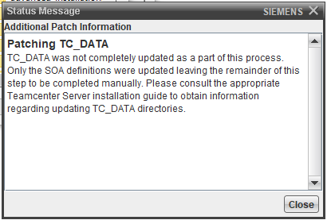
step17:install successfuly

